India tour 14-30 November 2018
Hotel days 8
Day 8 – Jodhpur, located South East of Jaisalmer some 328klm still in the desert region of Rajasthan.
Wednesday 21st November 2018 at Hotel Ajit Bhawan.
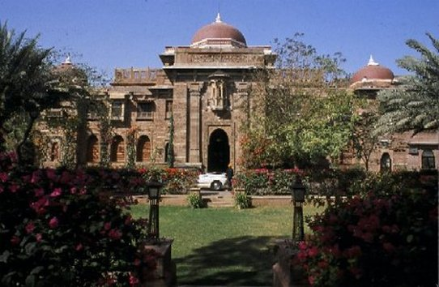
The bus trip from Jaisalmer to Jodhpur through semi-arid desert towards the South East of Rajasthan took over 5 hours including a lunch break. The Hotel Ajit Bhawan is set in spacious gardens with a main block building as a reception centre and several other accommodation wings. There are other individual accommodation units in a tent like structure to mimic the desert experience.
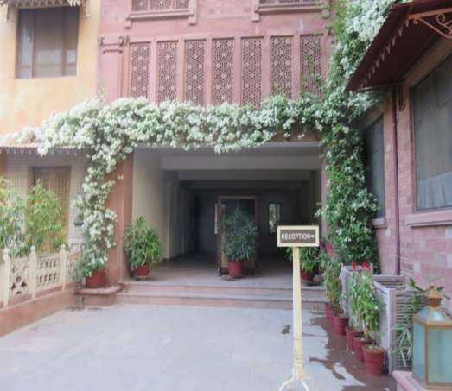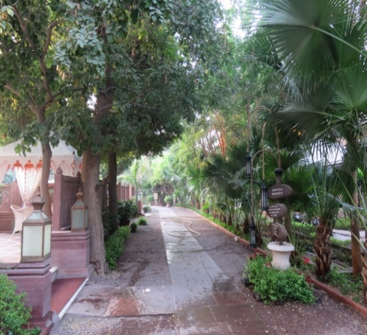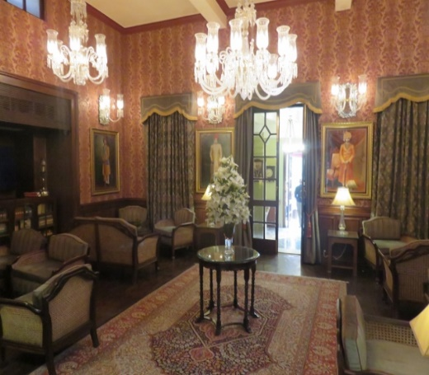
Reception entrance walkway to accommodation blocks reception lounge.
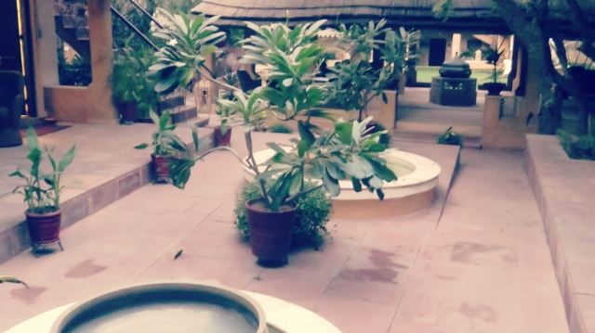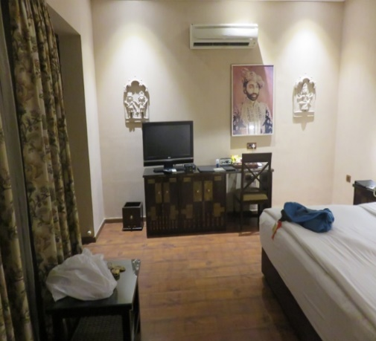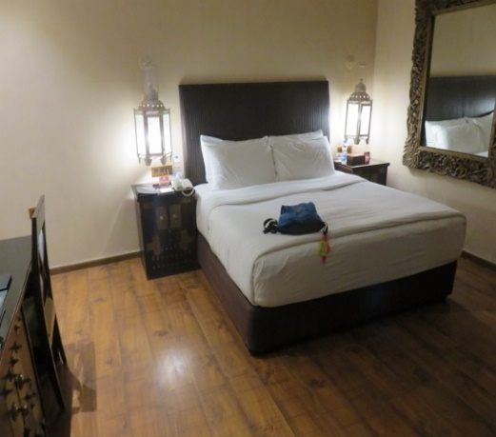
Court yard outside Alan’s room #80. View of his room from doorway Full size bed!

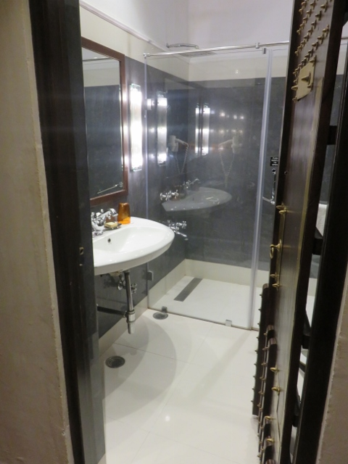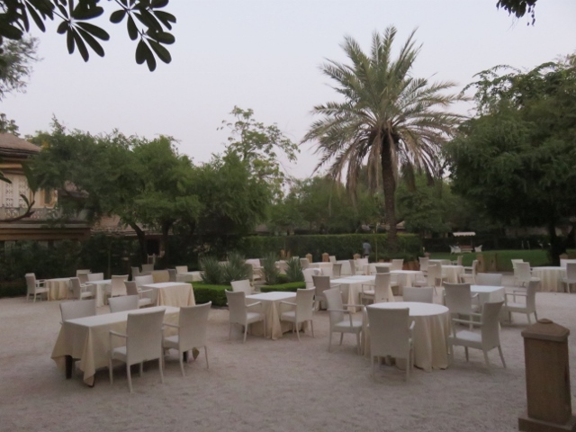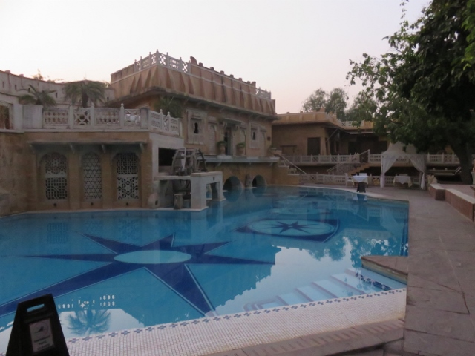
Alan’s bathroom outside dining area swimming pool next to guest rooms.
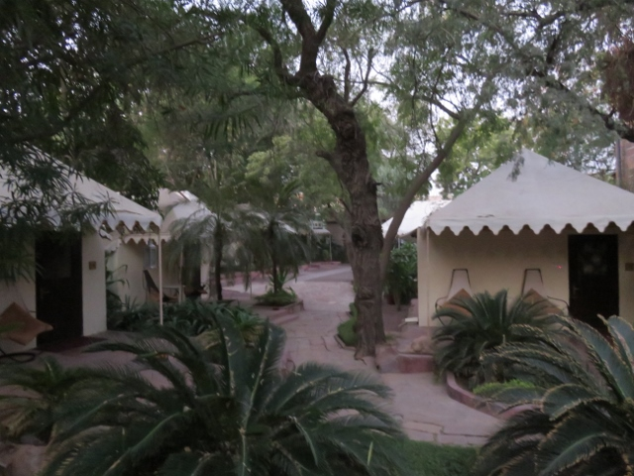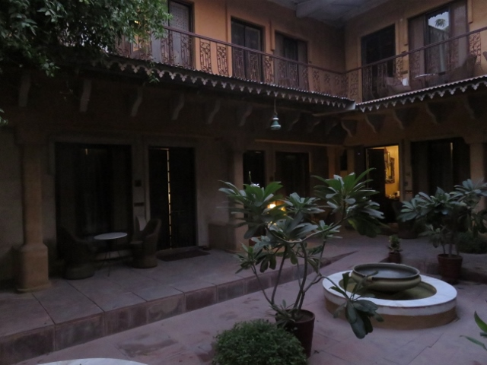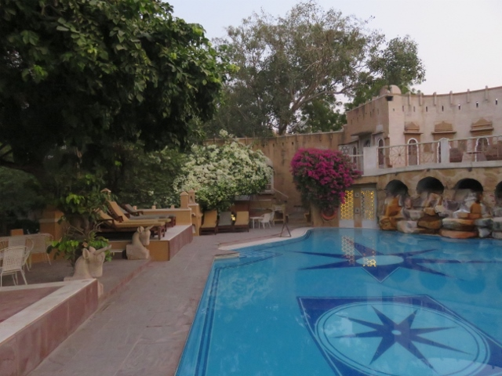
Individual tent units Alan’s room on left at dawn another view of swimming pool.

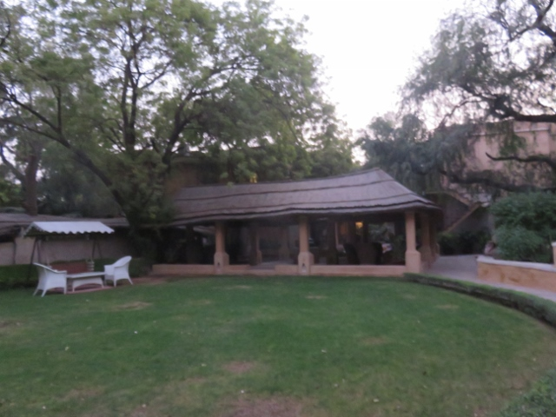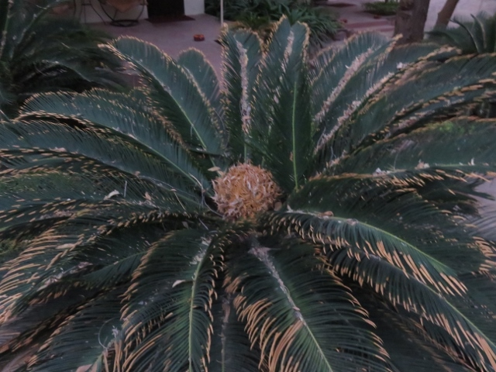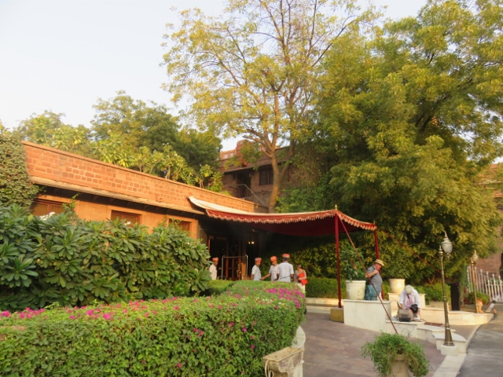
Open thatched meeting lounge tropical plants abound Staff waiting at main entrance.

This hotel was another fort like structure pretending to be rated as a 5 star outfit but was probably more like a 4 star rating. The rooms were difficult to find in the early evening light upon arrival and the rooms although large did not have the same quality and finish as previous hotels.

